Create two packages:

* library.models - This package will hold the classes that represent the data models (e.g., Book, User).
* library.services - This package will contain the interface and classes for the business logic (e.g., LibraryService).

Define an interface LibraryService in the library.services package with the following methods:

* addBook(Book book): Adds a new book to the system.
* removeBook(String bookId): Removes a book from the system.
* borrowBook(String userId, String bookId): Allows a user to borrow a book.
* returnBook(String userId, String bookId): Allows a user to return a borrowed book.
* getAvailableBooks(): Returns a list of available books.

CLASSES :

Book (in library.models):

* String id
* String title
* String author
* boolean isAvailable (true if the book is available, false if borrowed)

User (in library.models):

* String id
* String name

LibraryServiceImpl (in library.services):

* Implement the LibraryService interface in this class.
* It  
  should manage a collection of Book objects and perform the business   
  logic for adding, removing, borrowing, and returning books.
* The borrowBook method should not allow a user to borrow a book that is already borrowed.
* The returnBook method should not allow a book to be returned if it wasn't previously borrowed.
* The getAvailableBooks method should return a list of books that are marked as available (isAvailable == true).
* Write the necessary code to implement the above requirements across the packages and interfaces.
* Ensure that the LibraryServiceImpl class is properly structured and follows   
  the contract defined by the LibraryService interface.

Demonstrate how the classes interact with each other through an example.

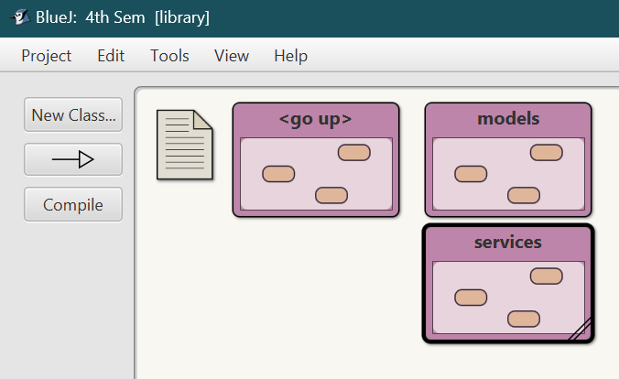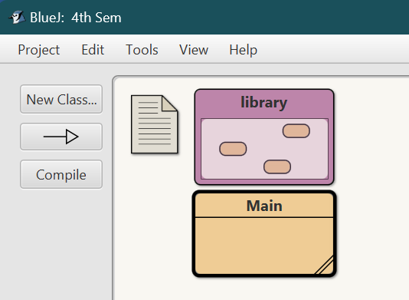Setup:

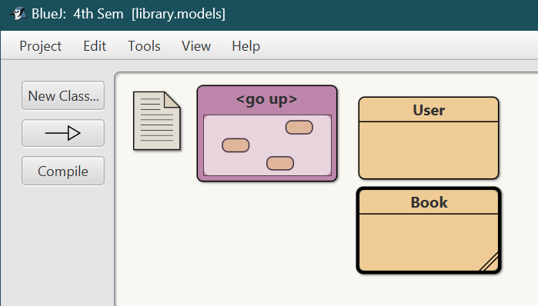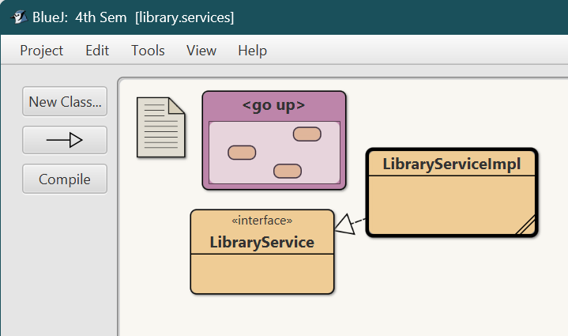

Main Class

import library.models.Book;

import library.services.LibraryService;

import library.services.LibraryServiceImpl;

import java.util.List;

public class Main {

public static void main(String[] args) {

LibraryServiceImpl service = new LibraryServiceImpl();

Book book1 = new Book("1", "BOOK1", "Author1");

Book book2 = new Book("2", "BOOK2", "Author2");

service.addBook(book1);

service.addBook(book2);

service.borrowBook("user1111", "1");

service.borrowBook("user2222", "1");

service.returnBook("user1111", "1");

service.returnBook("user2222", "1");

List<Book> availableBooks = service.getAvailableBooks();

System.out.println("Available books:");

for (Book book : availableBooks) {

System.out.println(book.id+" "+book.title);

}

}

}

User class

package library.models;

public class User {

public String id;

public String name

public User(String id, String name) {

this.id = id;

this.name = name;

}

}

Book class

package library.models;

public class Book {

public String id;

public String title;

public String author;

public boolean isAvailable;

public Book(String id, String title, String author) {

this.id = id;

this.title = title;

this.author = author;

this.isAvailable = true; // book is available by default

}

}

LibraryService interface

package library.services;

import library.models.Book;

import java.util.List;

public interface LibraryService {

public void addBook(Book book);

public void removeBook(String bookId);

public void borrowBook(String userId, String bookId);

public void returnBook(String userId, String bookId);

}

LibraryServiceImpl class

package library.services;

import library.models.Book;

import java.util.ArrayList;

import java.util.List;

public class LibraryServiceImpl implements LibraryService {

private List<Book> books = new ArrayList<>();

public void addBook(Book book) {

books.add(book);

System.out.println("Book added: " + book.title);

}

public void removeBook(String bookId) {

books.removeIf(book -> book.id.equals(bookId));

System.out.println("Book removed: " + bookId);

}

public void borrowBook(String userId, String bookId) {

for (Book book : books) {

if (book.id.equals(bookId) && book.isAvailable) {

book.isAvailable = false;

System.out.println("Book borrowed by User " + userId + ": " + book.title);

return;

}

}

System.out.println("Book " + bookId + " is not available for borrowing.");

}

public void returnBook(String userId, String bookId) {

for (Book book : books) {

if (book.id.equals(bookId) && !book.isAvailable) {

book.isAvailable = true;

System.out.println("Book returned by User " + userId + ": " + book.title);

return;

}

}

System.out.println("Book " + bookId + " was not borrowed.");

}

public List<Book> getAvailableBooks() {

List<Book> availableBooks = new ArrayList<>();

for (Book book : books) {

if (book.isAvailable) {

availableBooks.add(book);

}

}

return availableBooks;

}

}